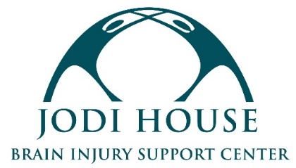

SPANISH INSTRUCTOR

REPORTS TO: Program Director
CLASSIFICATION: Volunteer or Independent Contractor

MISSION
Jodi House empowers brain injury survivors to not merely survive but thrive by providing support services that encourage their physical, cognitive, and behavioral recovery, regardless of the ability to pay.

SPANISH INSTRUCTOR POSITION SUMMARY
Jodi House’s Day Program allows survivors of brain injury to continue their cognitive, physical, and psycho-social recoveries through group classes. We are seeking a Spanish Instructor to lead a weekly group of 8-16 brain injury survivors through basic Spanish lessons with an emphasis on stimulating the brain and learning something new as opposed to mastering the language. The instructor would be a volunteer or a paid independent contractor (pay DOE).

INSTRUCTOR REQUIREMENTS
- Maintain a high level of professionalism and possess excellent interpersonal and communication skills
- Experience leading groups preferred, but not required
- Experience with brain injury survivors or adults with disabilities preferred, but not required. All training on members relations and safety will be provided by Jodi House
- Interest in leading the group long-term and building relationships with members
- Proof of COVID-19 vaccination required
- Completion of a background check required

SCHEDULE & LOCATION
- 1-hour group every week
- Availability between the hours of 10 AM and 4 PM
- Will report on-site to Jodi House at 625 Chapala Street, Santa Barbara, CA 93101
- Potential for additional virtual teaching opportunities

Interested candidates should submit their resume to gabby@jodihouse.org. Selected candidates will be contacted for an interview.

