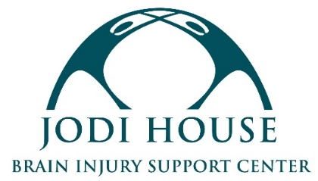

JOB DESCRIPTION: CASE MANAGER

REPORTS TO: Program Manager
CLASSIFICATION: Full-time; non-exempt.

MISSION
Jodi House empowers brain injury survivors to not merely survive but thrive by providing support services that encourage their physical, cognitive, and behavioral recovery, regardless of the ability to pay.

POSITION SUMMARY
Under the direction of the Program Manager, the Case Manager provides individual support and rehabilitation services to adult brain injury survivors and helps facilitate Jodi House’s Day Program.

ESSENTIAL JOB FUNCTIONS
- Provide one-on-one case management support to Jodi House members in furtherance of their individual recovery goals, including developing, evaluating and revising case management goals and plans.
- Assist members in aspects of independent living that include the development of social, vocational and effective life management skills.
- Develop trust and rapport with survivors in a linguistically and culturally appropriate way, utilizing available resources including translation services when needed.
- Recognize and assist members in emotional distress in developing appropriate coping and conflict resolution skills.
- Educate members and their families/caregivers about brain injury and effective symptom management.
- Assist members in building healthy peer and familial support networks.
- Facilitate classes, support groups, and the Immersion Services pre-vocational program as needed.
- Monitor home safety of members, conduct home visits as needed and make appropriate referrals to community resources.
- Monitor member safety at all times and take appropriate and timely action in response to urgent or emergency situations.
- Educate members in finding alternative community resources when the need arises and assist with the completion of necessary paperwork.
- Serve as a representative of Jodi House to the community and collaborate in various community partnerships.
- Work with highly sensitive information and maintain confidentiality.
- Collect and document program data and services in member database and prepare reports in a timely manner.
- Train and supervise research interns.
- Assist with special events as needed.
- Other duties as assigned.

DESIRED QUALIFICATIONS
- Bachelor’s, professional, or technical degree in a related field; MSW, LCSW or MFT preferred.
- Bilingual Spanish/English language abilities preferred.
- Experience or education related to working with adults with disabilities.
- Experience working in the social services field.
- Familiarity with social service resources in the Tri-Counties region.
- Excellent interpersonal and customer service skills with ability to communicate effectively, both in writing and verbally.
- Ability to organize and prioritize work and work independently.
- Ability to remain calm and take appropriate actions in stressful or emergency situations.
- Knowledge of relevant computer programs and other office equipment.
- Current CPR/First Aid certification, or willingness to obtain within 60 days of hire.
- Current California Driver’s License and proof of insurance.

SCHEDULE
Position is full time, in-person, 40 hours per week, and non-exempt. Business hours are 9am-5pm, Monday-Friday.

BENEFITS
Jodi House offers a generous benefits package that includes paid time off, health benefits, and an employee retirement plan option.

Interested applicants may apply by sending their resume and cover letter to info@jodihouse.org.

