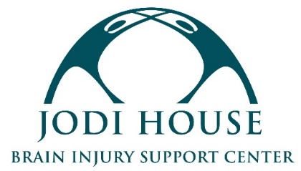

BILINGUAL GROUP INSTRUCTOR

REPORTS TO: Program Director
CLASSIFICATION: Volunteer or Independent Contractor

MISSION
Jodi House empowers brain injury survivors to not merely survive but thrive by providing support services that encourage their physical, cognitive, and behavioral recovery, regardless of the ability to pay.

POSITION SUMMARY
Jodi House’s Day Program allows survivors of brain injury to continue their cognitive, physical, and psycho-social recoveries through group classes. We are seeking a bilingual instructor who can lead a bimonthly cognitive class and support group for Spanish-speaking brain injury survivors. The instructor would be a volunteer or a paid independent contractor (pay DOE).

INSTRUCTOR REQUIREMENTS
- Maintain a high level of professionalism and possess excellent interpersonal and communication skills
- Experience leading groups preferred
- Fluent in Spanish
- Experience with brain injury survivors or adults with disabilities preferred, but not required. All training on members relations and safety will be provided by Jodi House
- Interest in leading the group long-term and building relationships with members
- Experience using Zoom
- Completion of a background check required

SCHEDULE & LOCATION
- 2-4 hours per month
- Availability between the hours of 10 AM and 4 PM
- On-site at Jodi House or Remote

Interested candidates should submit their resume to gabby@jodihouse.org. Selected candidates will be contacted for an interview.

