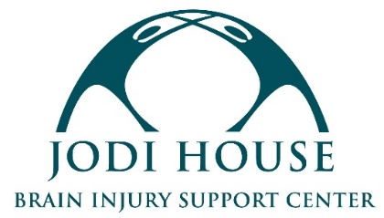

PROGRAM VOLUNTEER

REPORTS TO: Program Specialist
CLASSIFICATION: Volunteer

MISSION
Jodi House empowers brain injury survivors to not merely survive but thrive by providing support services that encourage their physical, cognitive, and behavioral recovery, regardless of the ability to pay.

VOLUNTEER POSITION SUMMARY
Under the direction of the Program Team, the Program Volunteer supports the successful operation of Jodi House’s Day Program. The Day Program allows survivors of brain injury to continue their cognitive, physical, and psycho-social recoveries through group classes, including Musical Mind Workout, Self-Defense, Posture & Stability, Brain Workout, and more. Volunteer positions are unpaid, but opportunities for academic credit are available if allowed through your school or class.

VOLUNTEER DUTIES
- Collaborate with Jodi House staff to support the daily operations of the program
- Assist with checking members in to classes
- Assist with classes and activities
- Help set up for and break down from classes
- Help with sweeping, cleaning, and organizing around the facilities
- Respectfully and kindly interact with Jodi House members, staff, and instructors
- Adhere to Jodi House policies and guidelines
- Uphold the standards of professionalism, sensitivity, and confidentiality

VOLUNTEER REQUIREMENTS
- Maintain a high level of professionalism and possess excellent interpersonal and communication skills
- Ability to work independently and take initiative
- Interest in social services/nonprofit sector preferred
- Experience with brain injury survivors or adults with disabilities preferred, but not required. All training on members relations and safety will be provided by Jodi House

SCHEDULE & LOCATION
- Ability to commit to a regular schedule of 2-4 hours weekly with a minimum of a 6-month commitment
- Availability between the hours of 11 AM and 4 PM
- Will report on-site to Jodi House at 625 Chapala Street, Santa Barbara, CA 93101

Interested candidates should submit the Jodi House Volunteer Application to info@jodihouse.org. Selected candidates will be contacted for an interview.

